Test plan for
<<project name>>

ChangeLog

Version | Change Date | By | Description
version number | Date of Change | Name of person who made changes | Description of the changes made

1 Introduction 2
1.1 Scope 2
1.1.1 In Scope 2
1.1.2 Out of Scope 2
1.2 Quality Objective 2
1.3 Roles and Responsibilities 2
2 Test Methodology 3
2.1 Overview 3
2.2 Test Levels 3
2.3 Bug Triage 3
2.4 Suspension Criteria and Resumption Requirements 3
2.5 Test Completeness 4
3 Test Deliverables 4
4 Resource & Environment Needs 4
4.1 Testing Tools 4
4.2 Test Environment 4
5 Terms/Acronyms 5

Introduction
Brief introduction of the test strategies, process, workflow and methodologies used for the project

Scope

In Scope

Scope defines the features, functional or non-functional requirements of the software that will be tested

Out of Scope

Out Of Scope defines the features, functional or non-functional requirements of the software that will NOT be tested

Quality Objective/APROACH

Here make a mention of the overall objevtive that you plan to achive withou your testing

Some objectives of your testing project could be

- Ensure the Application Under Test conforms to functional and non-functional requirements
- Ensure the AUT meets the quality specifications defined by the client
- Bugs/issues are identified and fixed before go live

Roles and Responsibilities
Detail description of the Roles and responsibilities of different team members like
- QA Analyst
- Test Manager
- Configuration Manager
- Developers
- Installation Team
Amongst others

Test Methodology

Overview

Mention the reason of adopting a particular test methodology for the project. The test methodology selected for the project could be
- WaterFall
- Iterative
- Agile
- Extreme Programming
The methodology selected depends on multiple factors. You can read about Test Methodology here

Test Levels

Test Levels define the Types of Testing to be executed on the Application Under Test (AUT). The Testing Levels primarily depends on the scope of the project, time and budget constraints.
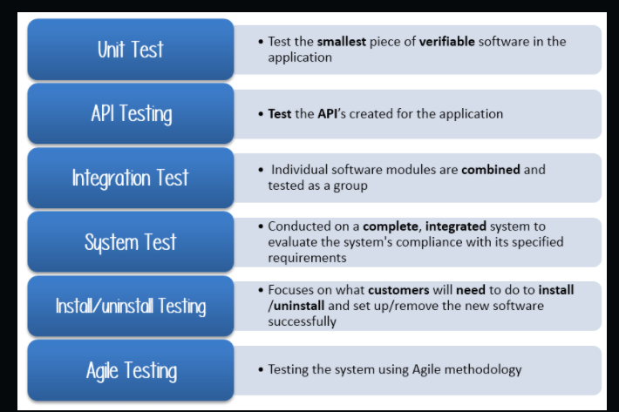

Bug Triage

The goal of the triage is to

- To define the type of resolution for each bug
- To prioritize bugs and determine a schedule for all “To Be Fixed Bugs’.

Suspension Criteria and Resumption Requirements

Suspension criteria define the criteria to be used to suspend all or part of the testing procedure while Resumption criteria determine when testing can resume after it has been suspended

Test Completeness
Here you define the criterias that will deem your testing complete.
For instance, a few criteria to check Test Completeness would be
- 100% test coverage
- All Manual & Automated Test cases executed
- All open bugs are fixed or will be fixed in next release

Test Deliverables

Here mention all the Test Artifacts that will be delivered during different phases of the testing lifecycle.

Here are the sample deliverables
- Test Plan
- Test Cases
- Requirement Traceability Matrix
- Bug Reports
- Test Strategy
- Test Metrics
- Customer Sign Off

Resource & Environment Needs

Testing Tools

Make a list of Tools like
- Requirements Tracking Tool
- Bug Tracking Tool
- Automation Tools
Required to test the project

Test Environment
It mentions the minimum hardware requirements that will be used to test the Application.

Following software’s are required in addition to client-specific software.

- Windows 8 and above
- Office 2013 and above
- MS Exchange, etc.

Terms/Acronyms
Make a mention of any terms or acronyms used in the project

TERM/ACRONYM | DEFINITION
API | Application Program Interface
AUT | Application Under Test

